Presents

Hackathon AFourathon 2.0 - 2023

AFour Digital Asset Design, Engineering And Support Guide

Solution

**Solution Purpose**

This project aims to reduce customers manual efforts for generating status reports by providing a web application.

**Objectives**

The solution solves the following problem statements and it’s sub systems.

1. Daily status reporting problem.
2. Weekly status reporting problem
3. Skills database problem

**Scope and No Scope**

The project scope is a outline that includes functionalities, resources and deliverables of our project. This project scope is extensive.

In Scope

* Project management application.
* Teams management application.
* Status management application.
* Email reporting application
* Employee management application
* Role based access control.
* Logging and Monitoring application.
* Docker Containerization
* Cloud Deployment

Out of Scope

* Token based authentication (extensive)
* Automation Testing (extensive)

Design

**UX Design**

Following are the wire-frames of our UI.

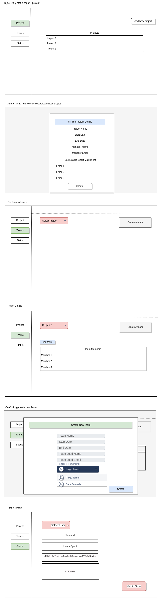

**UI Design Samples**

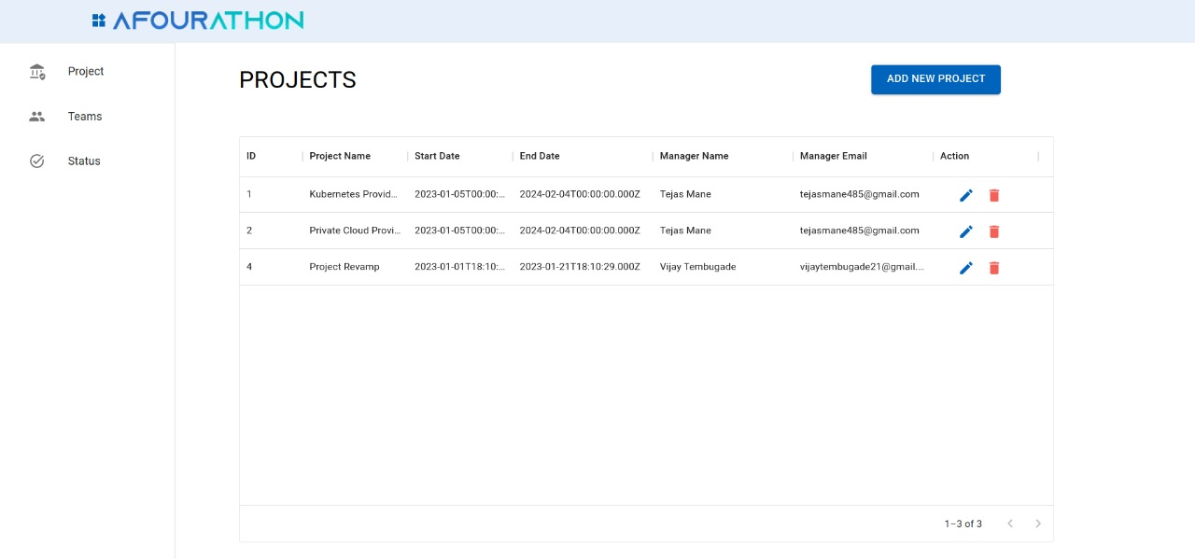

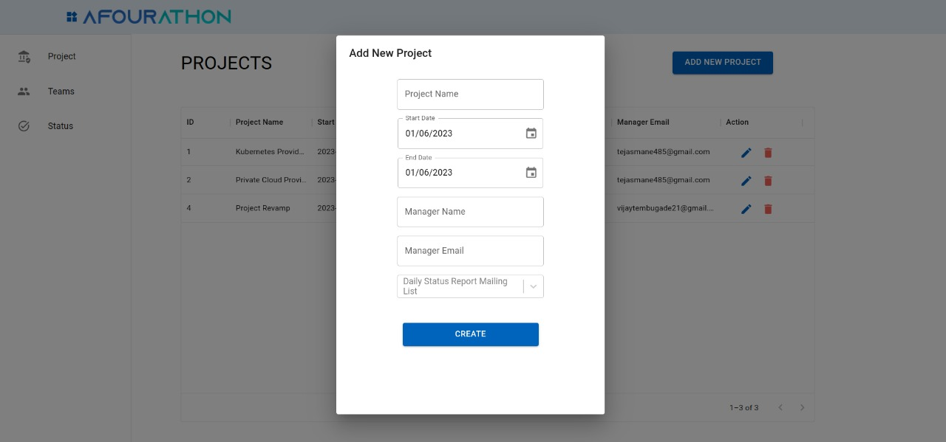

**Database Design**

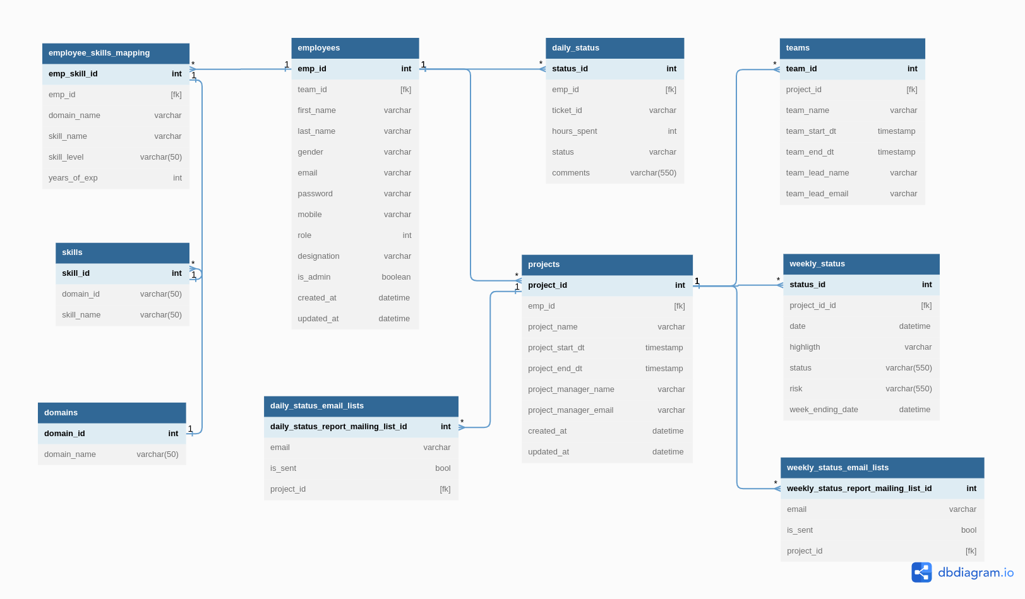

**API Collection.**

API Client: Thunder Client

API collections is attached to the link and

**Github link:** https://github.com/iamtejasmane/afourathon-2023

**Database ORM**

We have used the Sequelize ORM for the database. We have also provided the instance creation code for connection multiple database instances and read replication.

Development

**Source Code/Git**

GitHub URL - https://github.com/iamtejasmane/afourathon-2023

**Branching strategy**

Feature branch should be created from master and after completion of a feature, branch should be merger into master branch.

**Setting up Developer Machine**

* Clone the repository
* Go to the each project directories and installed the packages using `npm install`
* Run `npm start`
* The front end wil up on port number 3000

Testing

**Test Scope**

Scope

* Manual API testing
* Manual UI testing

Out of Scope

* Automation testing (extensive)

Backup and Recovery

**Database backup and recovery**

Run the following command to take backup:

`docker exec [container-name] sh -c ‘exec mysqldump –all-databases -uroot -p “$MYSQL_ROOT_PASSWORD”’ > /some-folder/db_backup.sql`

To restore the data use:

`docker exec [container-name] sh -c ‘exec mysql -uroot -p “$MYSQL_ROOT_PASSWORD”’ < /some-folder/db_backup.sql`

Monitoring

We have provided monitoring application which is performing a cron job after every 5 mins to check all the services are up and running.

If any services is down and unreachable, then it sends the email to the respective admin users.

Routine Maintenance

**Provide areas for routine maintenance on the following areas:**

* Service/Size Limit Evaluation
* Third party libraries renewal
* Other dependencies renewal (e.g. NPM packages)

Emergency Maintenance

**Point of Deployment Contacts**

Tejas Mane: [tejasmane485@gmail.com](mailto:tejasmane485@gmail.com)

Vijay Tembugade: karishma30deshmukh@gmail.com

AFour Technologies Pvt. Ltd. Office 501, 5th Floor, Sterling Tower,  
Pan Card Club Road, Baner, Pune 411045, India